What the map shows:
The initial map view shows all coffee shop locations contained in the database.
Each of the points on the map is a database record. The front end requests via an SQL statement, “the geom” and additional information for each of the points and render them on the map. “The Geom” is the geometry (X coordinate, Y coordinate) in other words, the geographic reference to where our point exists on the map. These points are also recorded in a manner which is associated with our chosen reference system. (WSG84 epsg:3857 CRS)
With each filter button the the server set invisible to the markers on the map for which the search string doesn't match.
for example : by coffee> 3fe
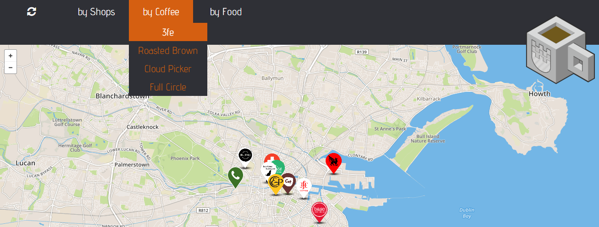
fig 4.1
The site sets all those shops for whom the 'coffee1' field is not defined as “3fe” as invisible, thus effectively removing them from the map.

Some of the other search criteria are more complex for example:
for example: by shops>business friendly
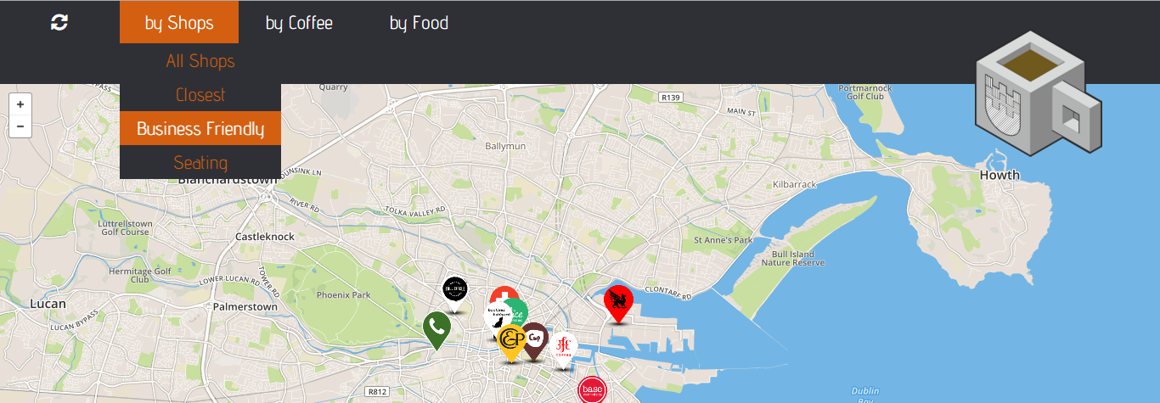
fig 4.2
Having interviewed a number of coffee shop owners, I determined that a shop might be deemed business friendly if it had a number of attributes:

seating Can someone sit down with their laptop?
wifi Is wifi available to allow someone to work?
power Are power sockets available to charge laptops / phones?
Service Is table service available? its not conducive to staying in a place if you have to either pack up your laptop / notes and take your bag with you to get a refill of coffee or leave them at the table unattended.

In this instance, we perform a SQL search something like
SELECT all FROM 'coffeeshops'
WHERE seating like '1' &&
WHERE wifi like '1' &&
WHERE power like '1' &&
WHERE service like '1'
ORDER by 'distance'
LIMIT to 5

The site has gone through a number if design iterations and the decision to show the 5 closest shops was taken rather late in the day, having tested the site with live data. I had originally chosen to show only the closest shop by Euclidean distance. If I were to specify the closest shop only, I would add (ORDER BY 'Distance' LIMIT to '1')

I found that the site was sending me 2 miles across the city to find a shop that matched criteria when a similar shop, say, without power sockets, might be within a few metres distance. This is a flaw, which I have a solution to but did not have time enough to implement and test.
The solution involves a trigger upon the change of any record involving the seating, wifi, power or service columns. The trigger adds up the values in the cells and writes this value to the business column, this would allow me a star rating system not giving preference to any one attribute over another.
I could then choose to order by business returning those shops with a 4 star business rating first, then ordering by distance, meaning that if there are 6 shops matching the criteria, then the closest five are shown, whereas if there is only one 4 star shop, but seven or eight more which are 3 star, then the matching 4 star shop is automatically part of the results table returned, and the four closest 3 star shops make up the returns. I think this is a far more robust solution, but time was against me and I reverted my site to an earlier 'working' version for submission.

I am aware that the complexity of the filtering criteria being used could be increased, but with that comes an increased complexity for the user and considering I anticipated this website being used primarily on a phone sized handset, I felt that increased text and complexity of a menu system might restrict the usage and uptake of the site. Also as part of my interviews, it was suggested that I remove as much of the wording as possible from the site unless I was going to make it multi lingual.

